**A Robust Image Zero-watermarking using**

**Convolutional Neural Networks**

**THEME OF THE PROJECT:**

This algorithm is based on the Convolutional Neural Networks (CNN) and deep learning algorithm, in which robust inherent features of image is generated by the CNN, and it is combined with the owner’s watermark sequence using XOR operation.

**WORKING PRINCIPLE:**

In this paper, we propose a deep learning-based zero watermarking scheme, in which the inherent features of image are constructed through the training process of the CNN. Once the CNN is trained, we obtain the output of the first fully connected layer (*fc_1*) and link it with the owner’s watermark sequence to generate master share. In the image verification stage, the image under analysis is introduced to the pre-trained CNN to obtain its inherent features, which are used to obtain the watermark sequence.

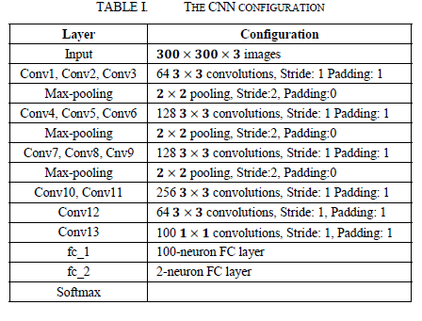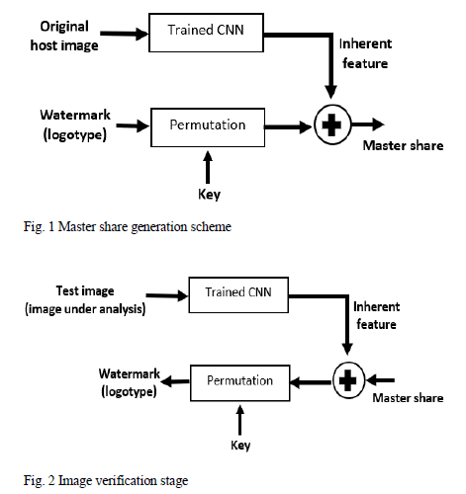

The trained CNN is shown in table 1.

**CODING FLOW:**

* Consider an input image and add different types of noises / filters / compression / rotation.
* Extract the inherent features of that input images using network which is created through the layers shown in table 1.
* By using Activations we calculate the inherentfeatures.And are resized with 10 X 10.
* Consider another image which is secret image. It is resized with 10 X 10
* The inherent features and the hidden image are combined with Xor operation to form mater share image.
* To extract the hidden image as to perform the xor operation of master share image and inherent features.

**SIMULATION PROCEDURE:**

Run the main.m .

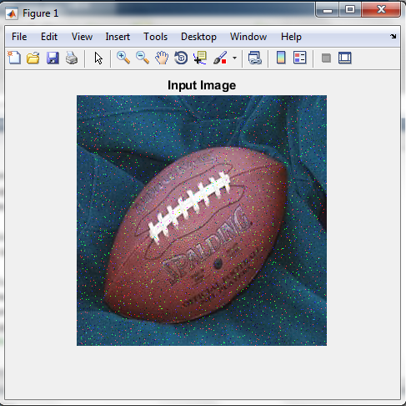 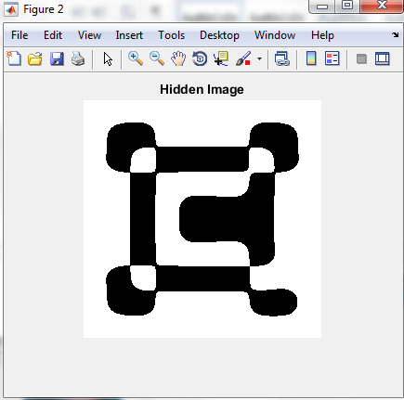

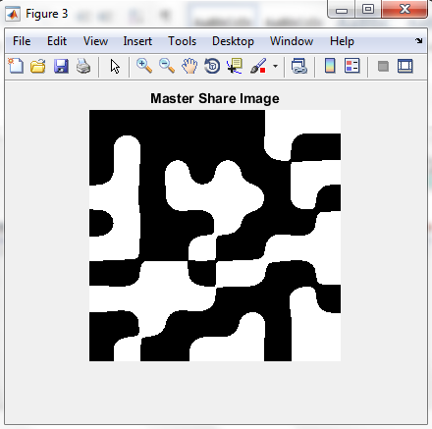 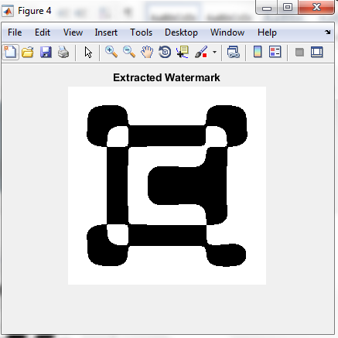

**FUTURE EXTENSION IDEA:**

**-**

**DEVELOPED BY:** SHAIK.RESHMA

**VERIFIED BY: E. Naga Keerthana**

**LAST UPDATE:**